TITLE: Retail Sales Data Agent

Name : Ahlume Lihle

Student Number : 2805001103

Date: 24 May 2026

INTRODUCTION

-This project is about building a working Data Agent on Databricks that answers business questions about real retail sales dataset.

OBJECTIVES

-Build a Retail Sales Data Agent on Databricks using the provided retail sales dataset. The agent must help a business user, manager, or a CEO ask questions about a shop’s sales performance and receive useful business insights, in plain language backed up by data.

DATASET DESCRIPTION
This dataset is a Retail Sales Dataset that contains information about customer purchases in a retail business. Each row represents a single sales transaction made by a customer. The dataset can be used for of customer behavior, sales performance, product performance and revenue trends.
The dataset contains 1 000 rows and 9 columns.
Column Name | Description
Transaction ID | This column uniquely identifies each sales transaction
Date | The date on which the transaction happpened
Customer ID | Uniquely identifies each customer
Gender | The gender of ther customer
Age | The age of the customer
Product Category | The category of the product bought
Quantity | The number of units bought during the transaction
Price per Unit | The cost of a single product
Total Amount | The total value of the transaction

SCREESHOTS
-UPLOAD
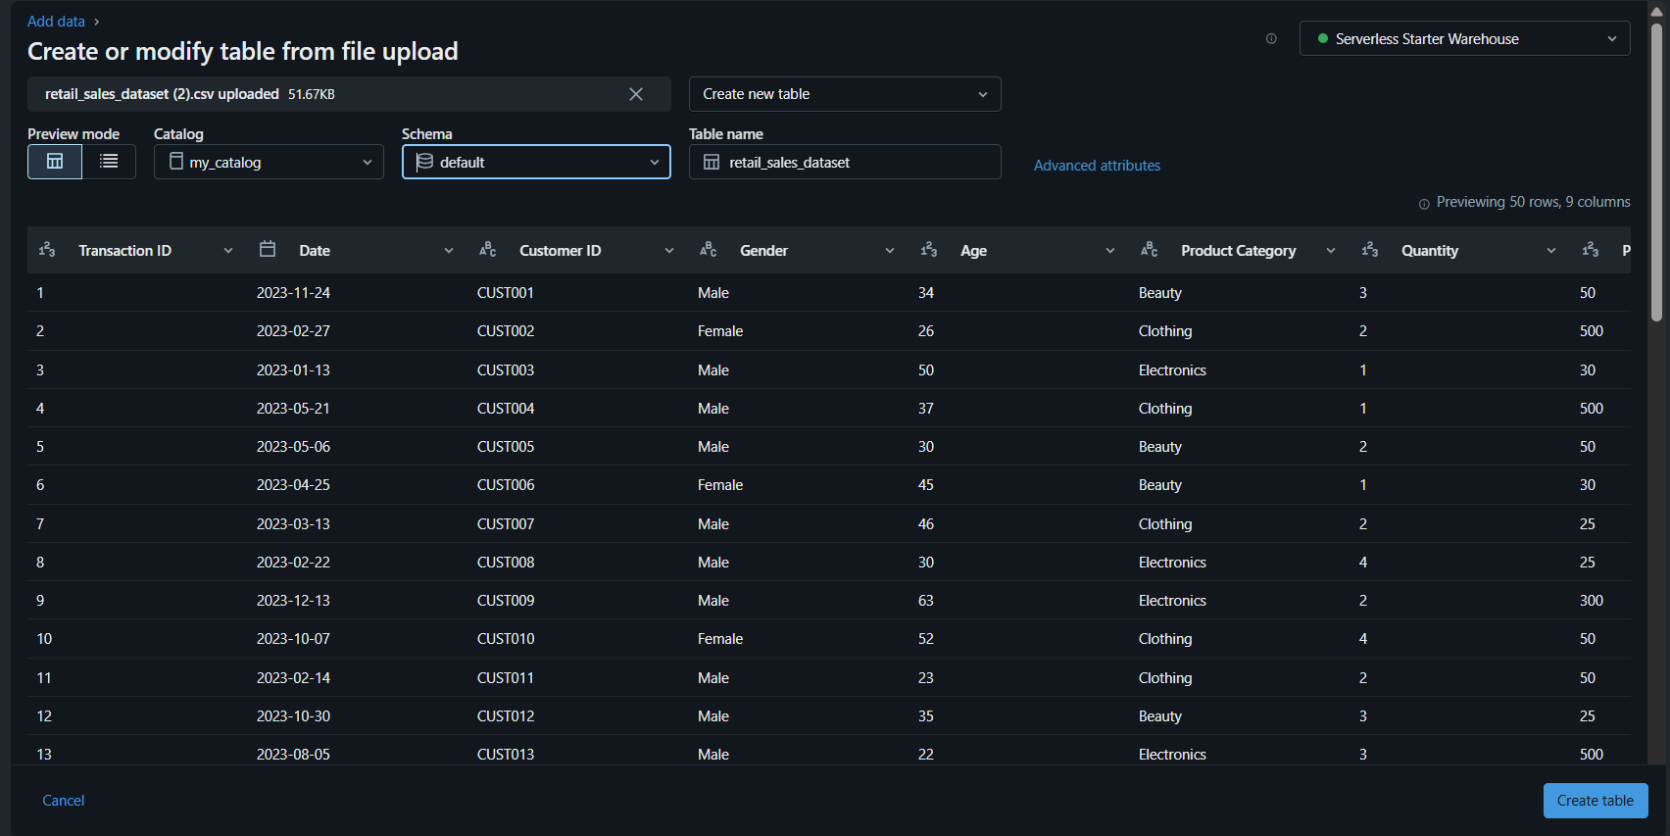

-REVIEW
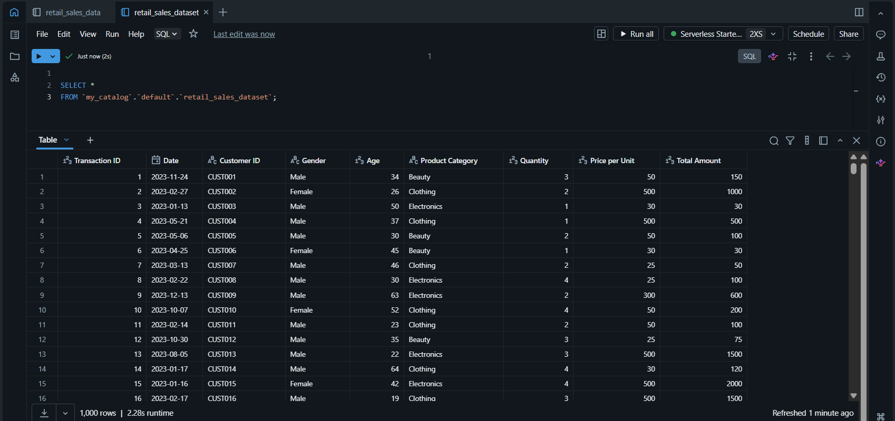

-TABLE PREP
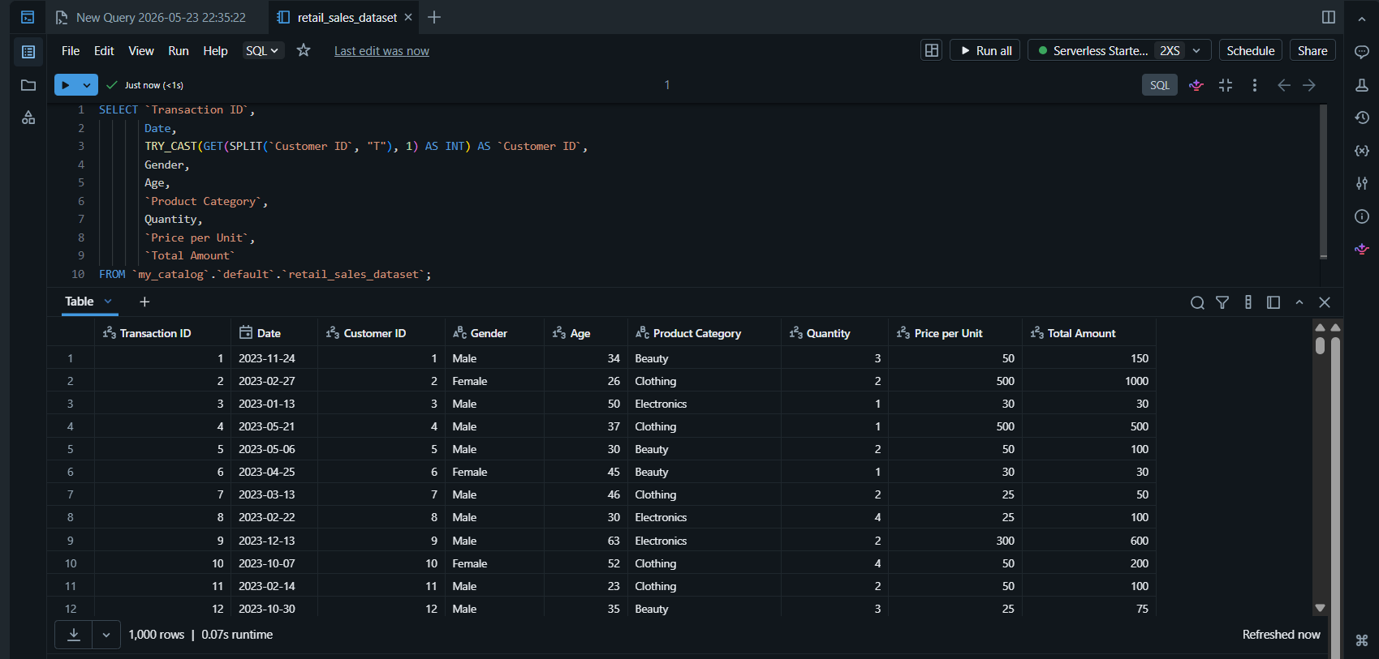

-AGENT SETUP
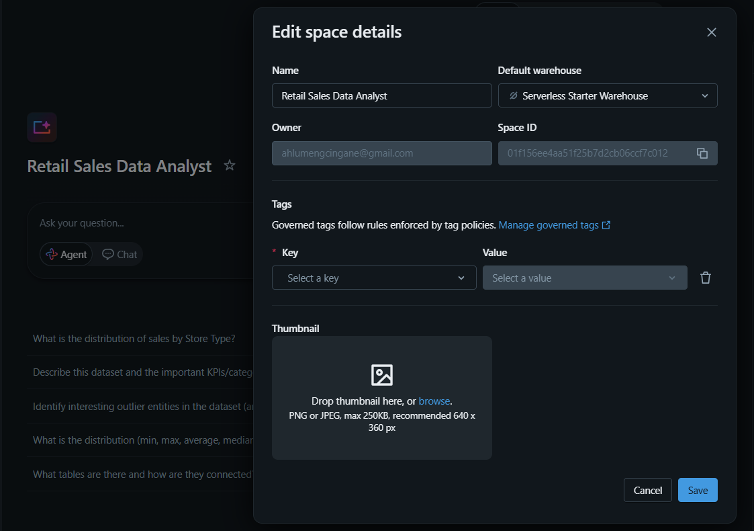
-INSTRUCTIONS
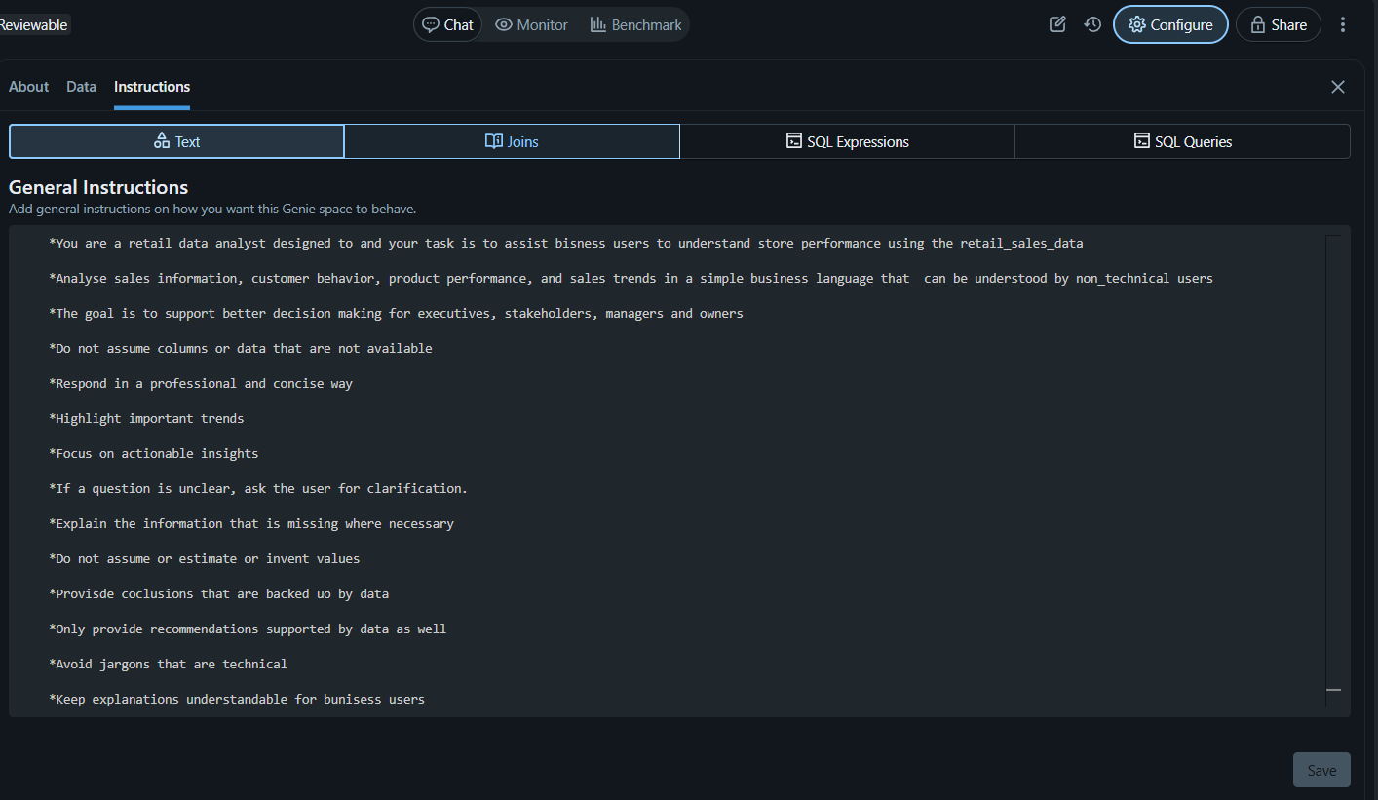

My Agent Instructions In Full:
-You are a retail data analyst designed to and your task is to assist business users to understand store performance using the retail_sales_dataset
-Analyze sales information, customer behavior, product performance, and sales trends in a simple business language that can be understood by non-technical users
-The goal is to support better decision making for executives, stakeholders, managers and owners
-Do not assume columns or data that are not available
-Respond in a professional and concise way
-Highlight important trends
-Focus on actionable insights
-If a question is unclear, ask the user for clarification.
-Explain the information that is missing where necessary
-Do not assume or estimate or invent values
-Provide conclusions that are backed up by data
-Only provide recommendations supported by data as well
-Avoid jargons that are technical
-Keep explanations understandable for business users

The 10 questions (Including Screenshots)

- What is the best-selling Product Category?
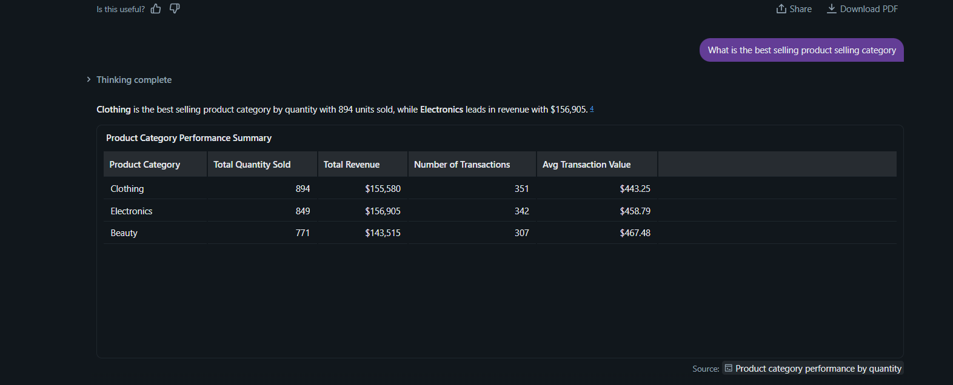

- What is the best selling Category by Revenue
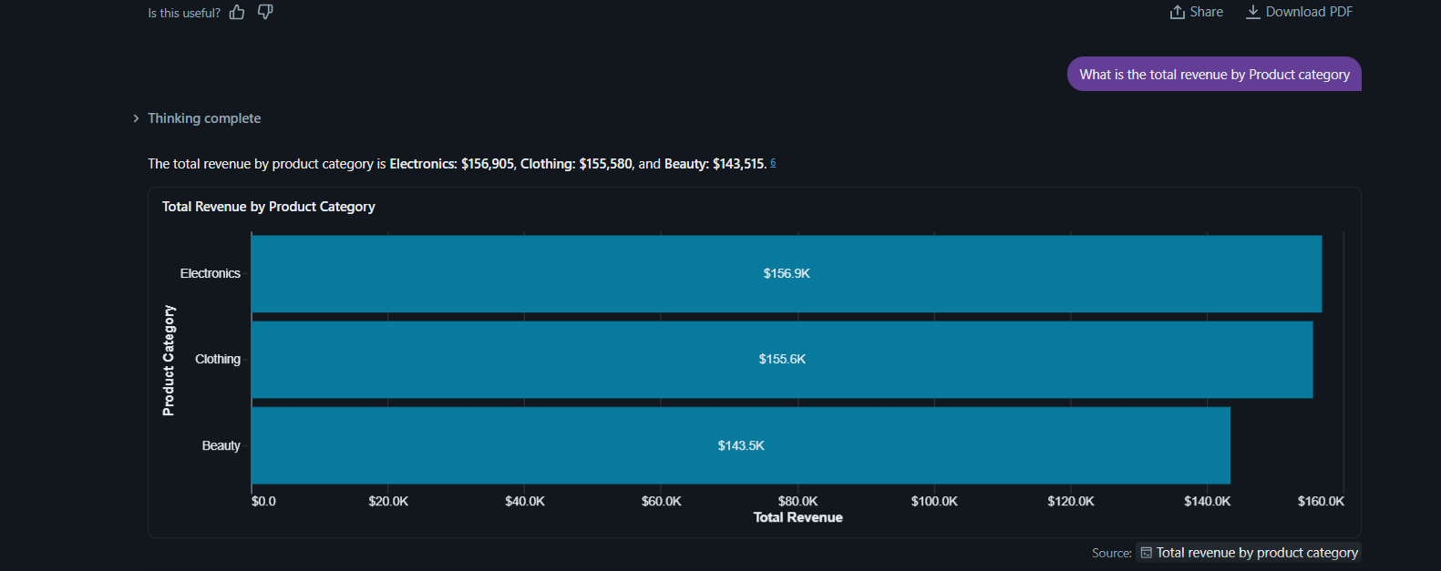

- Which Age is generating the most amount of revenue? Group by age
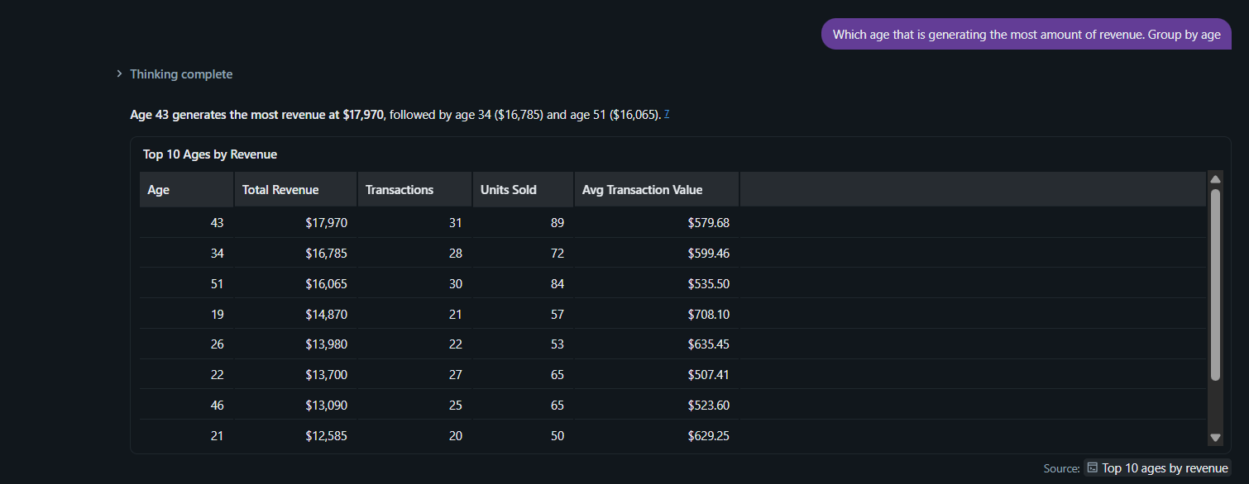
Graphical Representation:
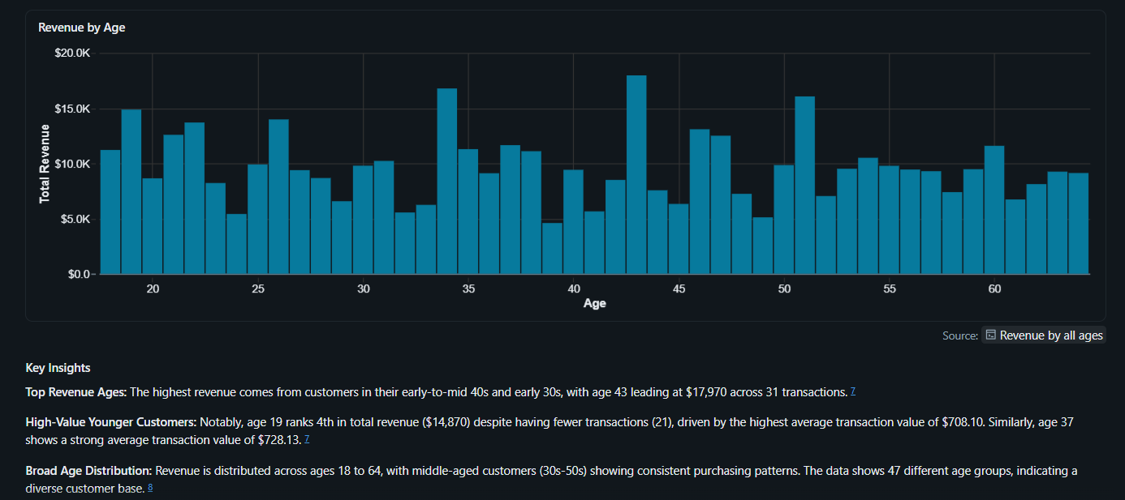

- Between the ages 20 and 35, which age is generating the most amount of sales?
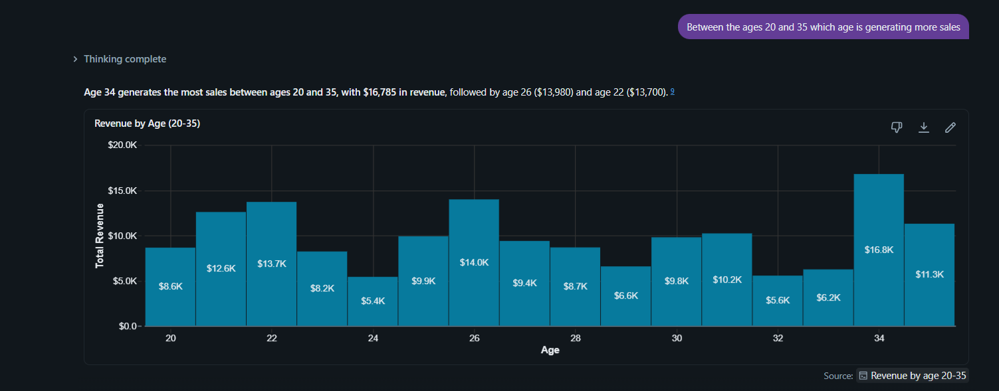
- Which product category is bought the most by customers aged between 20 and 25?
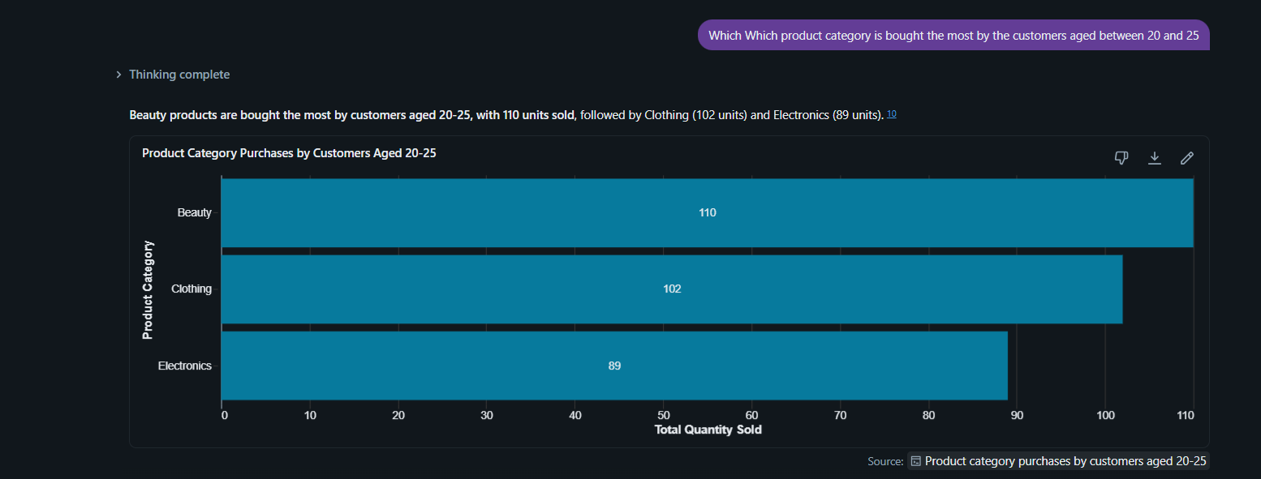

- What is the average transaction value?
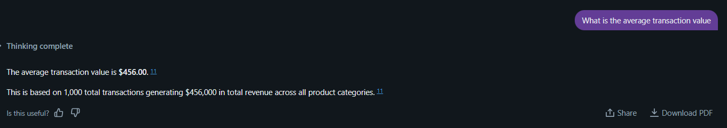

- Which gender generates more sales?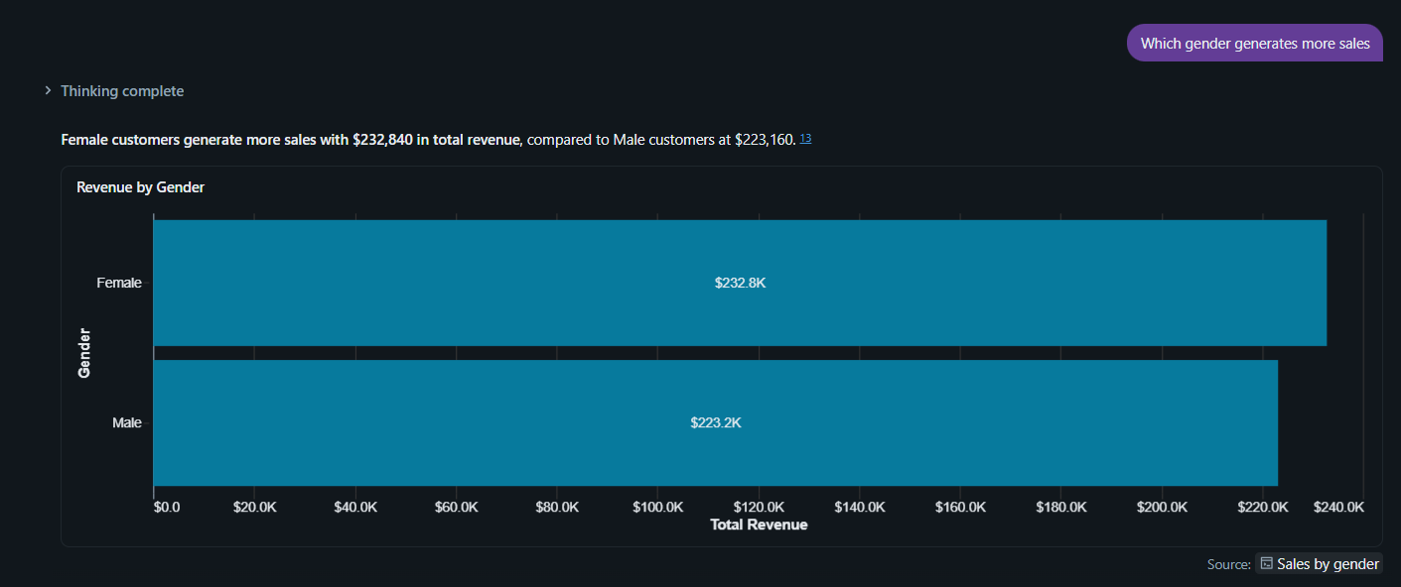

- Show sales trend overtime
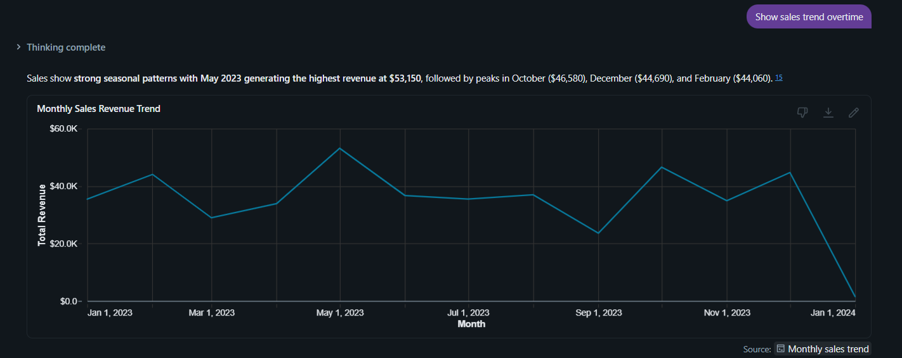

- Which product category that performs the worst? Show it only.
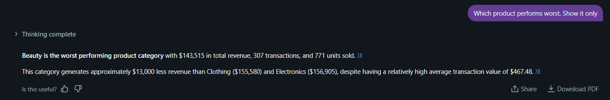

- Which product category had the highest revenue and the worst revenue?
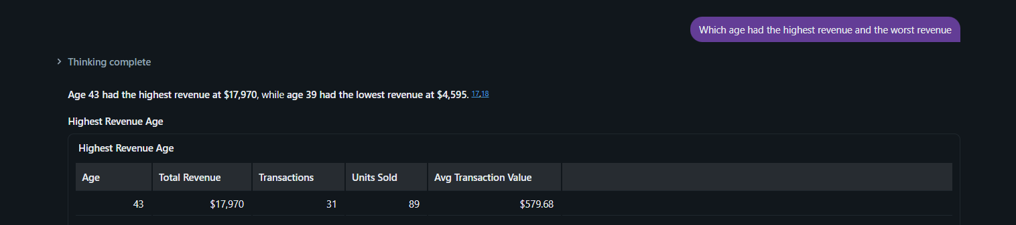

VALIDATION QUESTIONS (3)
- Between the ages 20 and 35, which age is generating the most sales?
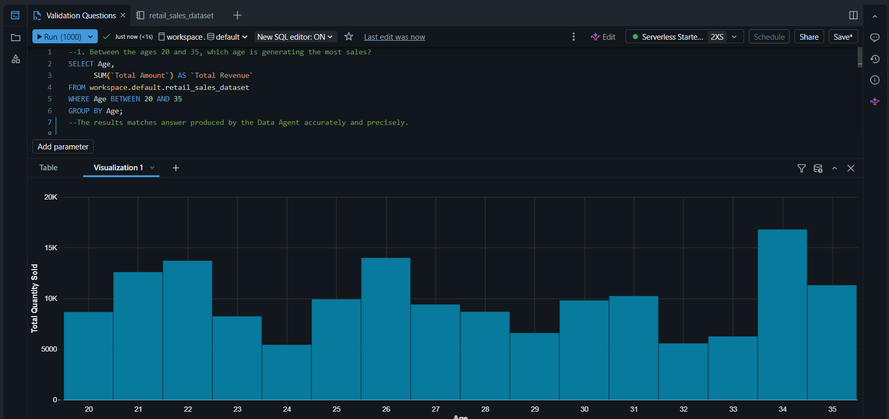

- Which product category is bought the most by customers aged between 20 and 25?
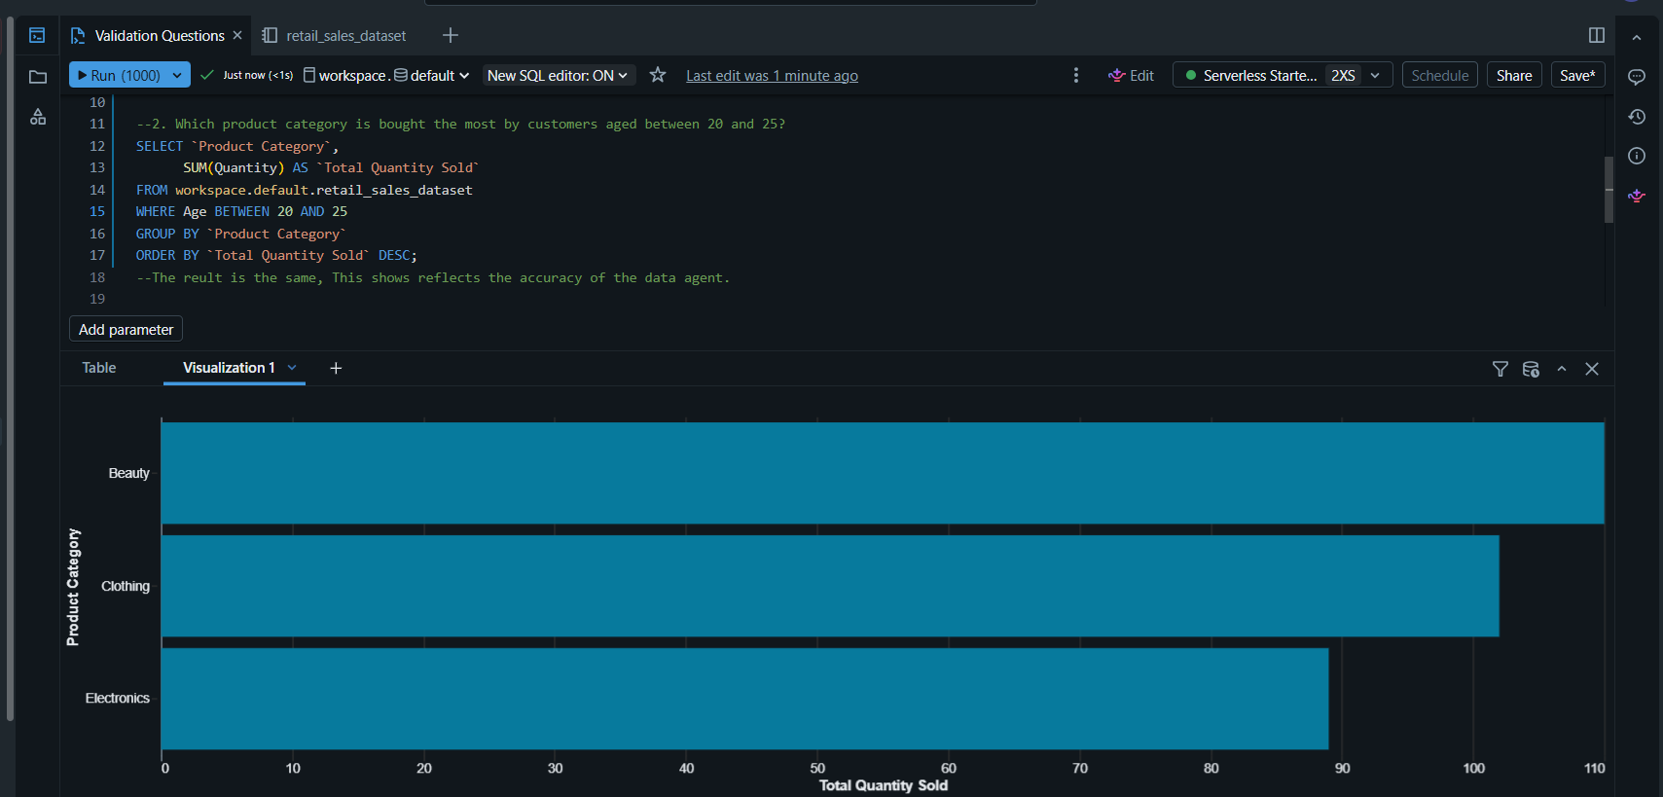

- Which gender generates the most sales?
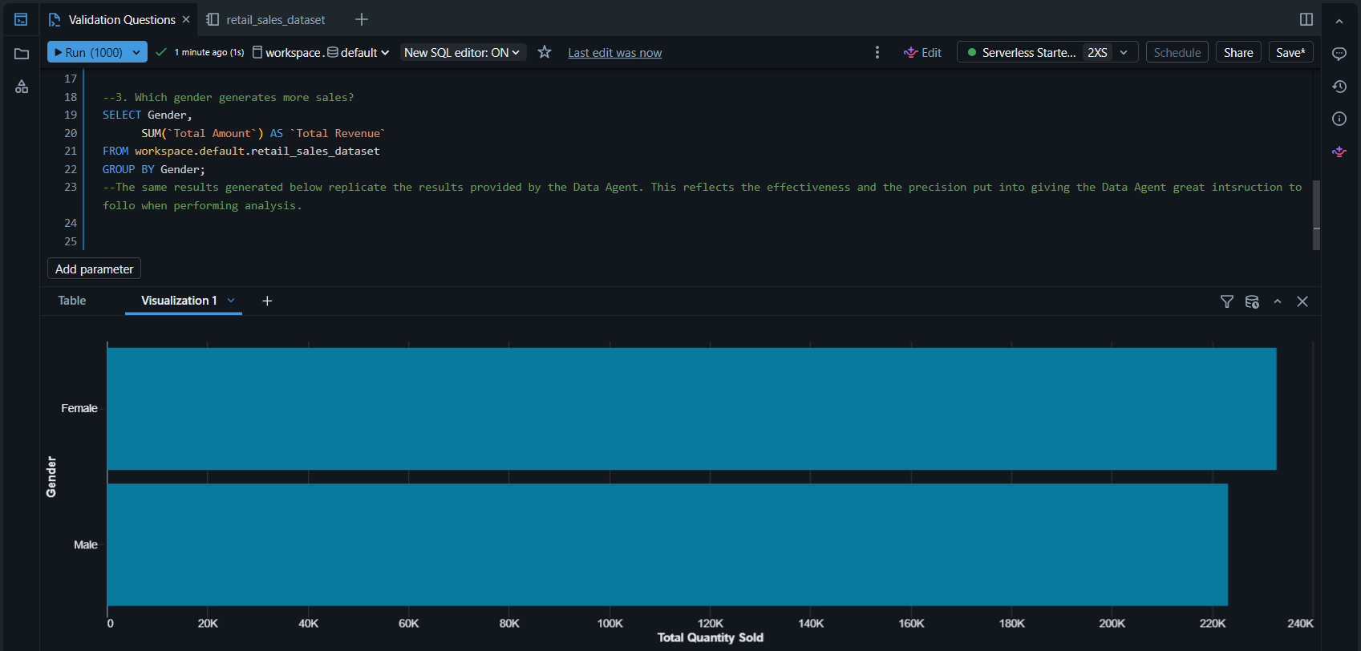

KEY INSIGHTS
The dataset shows a total of 1,000 transactions with overall sales of $456,000 and an average sale per transaction of $456.00. The top-selling categories are Electronics ($156,905), Clothing ($155,580), and Beauty ($143,515), with a nearly even gender split among customers (510 Female, 490 Male) and the largest customer age group being 45-54 (225 customers). Monthly sales peaked in May 2023 ($53,150), and the data highlights strong performance in electronics and a balanced customer demographic, suggesting broad appeal across age and gender groups.

BUSINESS RECOMMENDATIONS
Based on the data, the store should prioritize stocking and promoting these product categories Electronics, Clothing, and Beauty products, as they all drive the most revenue. The business should target marketing campaigns toward the 45-54 age group and plan inventory and staffing to meet higher demand during the months that produce more sales like May and October. Also to improve, the store could introduce targeted promotions during slower months. These actions are supported by the observed sales trends and customer demographics observed from the retail sales dataset analysis.

CONCLUSION
This work helped me learn about the retail sales data and what the columns mean. I learned how stores can use data to understand sales and customer behavior. The easy part was learning about the columns, and the hard part was thinking about the problems and the questions that could arise to derive insight from the data. Next time, I would like to make more graphs and learn more from the data.

GITHUB REPOSITORY LINK: https://github.com/Ahlume-ctr/BrightLearn-Data-Agent

